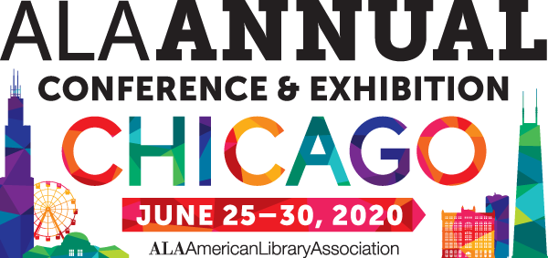

Making your case to attend

Making the case for time off and support for travel and expenses to attend a conference requires a solid understanding of the potential benefits to your institution, supervisor, and colleagues. And you need to be able to communicate those benefits clearly—especially in times of tight budgets and reduced staff. Use this sample memo to help make your case.

Sample memo to your boss
explaining why your attendance at the conference
is a good investment.

To: Your Boss
From: You
Re: Attendance at the 2020 ALA Annual Conference & Exhibits
Date: As early as possible

The 2018 ALA Annual Conference takes place in Chicago, IL on June 25-30, 2020. This event has the reputation for being a top educational and networking opportunity for librarians. With the theme “Transforming our libraries, ourselves,” the emphasis of programs, sessions, discussions, and updates is focused on the future and on tools to help libraries adapt, stay strong, and improve services despite tight budgets.
The networking opportunities have an outstanding track record for bringing long-term professional benefits, including sharing ideas and best practices throughout the field.
If I am supported to attend 2020 ALA Annual Conference, here are some ways in which I would ensure that the investment pays dividends for the library, and how I would make the most of the opportunity for professional development.
[If you are a committee member or participate in ALA activities, list related meetings you plan to attend and why, how your participation can help the profession, your library, and your own professional development.]
[The following are suggested ways to talk about how you would spend your time.]
I would attend the following programs, among others:
- List 4-5 programs related to your work and why they will help you do your job better
- Program 2
- Program 3
- Program 4
I would plan on spending a minimum of xx hours in the exhibit hall. I would meet with our current vendors as appropriate, to build our personal relationships. I would focus on vendors and new product demonstrations in the following areas, looking for cost-effective innovations and new products, doing comparison shopping, and positioning us for negotiating best terms:
- Current vendor(s)—list
- Vendors in a specific area/field
- Vendors by name
- New products I’ve read or heard about and wish to see demos of etc.
The networking at ALA conferences is outstanding. I would represent our library as forward-thinking and dynamic in my interactions with people I meet, and would seek to connect with people whose ideas and specializations seem most likely to benefit our library as well as contribute to my professional development and education, making me increasingly effective in my job. I would network with people I meet while attending sessions, discussions, programs, and events, and would also plan to make the most of specific networking opportunities [such as Library Unconference, Networking Uncommons, etc.].
After I return, I would take the following steps to ensure that what I learn benefits the library:
- Implement at least one new idea that makes us more efficient and/or effective.
- Share notes on sessions
- Share my list of action items and general ideas
- Provide a written report
I would need xx days away from work to attend. The costs are as follows:
[import from budget worksheet]
It would be beneficial, as we would save money by qualifying for a discounted registration, if we can decide before the early bird registration ends on March 6, 2019.
Thank you for your consideration.
[Name]

